**Assignment 2**

**Problem Statement:** Facial recognition using OpenCV and deep learning for binary classification.

**Library:**

1. **OpenCV**: Open-source library for computer vision. It is primarily used for real-time image and video processing, including facial detection and recognition tasks.
2. **Keras / TensorFlow**: Deep learning libraries that provide easy-to-use APIs for defining and training neural networks.
3. **NumPy**: For handling numerical data and performing array manipulations.
4. **scikit-learn**: Library used for preprocessing, model evaluation, and possibly model selection.
5. **Matplotlib/Seaborn**: For data visualization and plotting model performance metrics.

**Theory:**

Facial recognition using deep learning involves detecting faces from images and classifying them into different categories. In binary classification, the goal is to categorize an image as either belonging to class A or class B (e.g., "Known" or "Unknown").

The process generally involves:

1. **Face Detection**: Using OpenCV's Haar cascades or deep learning-based methods, faces are detected in an image or video stream. OpenCV provides pre-trained models for face detection, which can be quickly integrated.
2. **Feature Extraction**: The detected face is then processed to extract relevant features, such as pixel intensities, facial landmarks, or more complex features like embeddings from a pre-trained model (e.g., VGG-Face, FaceNet).
3. **Binary Classification**: A deep learning model is trained to classify the extracted facial features into one of two categories. This model typically includes convolutional neural networks (CNNs) to handle the spatial hierarchies of the input image data.

The facial recognition system leverages the power of CNNs, which can capture spatial features from the input image, making them suitable for facial recognition tasks.

**Methodology:**

1. **Data Collection and Preprocessing**:
   * Use OpenCV to detect faces in images or video frames.
   * Preprocess the images by resizing, normalizing, and possibly augmenting them to increase the training data's variety and robustness.

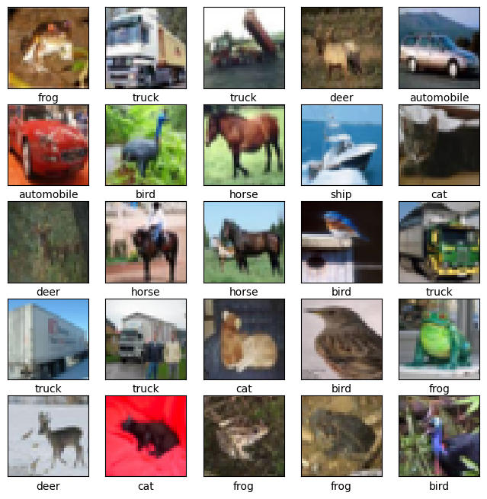

1. **Model Definition**:
   * Define a deep learning model (often a CNN) for binary classification. The model may use layers like convolutional layers, pooling layers, fully connected layers, and a softmax or sigmoid activation function in the final layer for binary classification.
2. **Training**:
   * Train the model using a labeled dataset where each image belongs to either class A or class B. Backpropagation and an optimizer such as Adam are used to minimize the loss function.
   * Track accuracy, precision, recall, and loss during the training process.

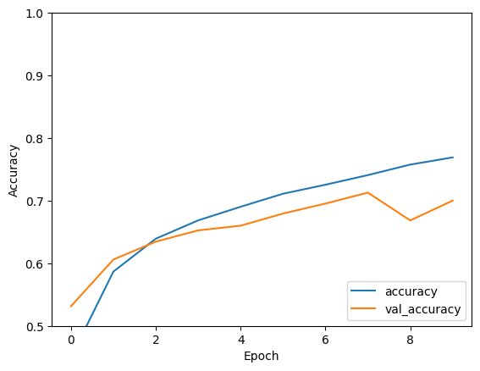

1. **Model Evaluation**:
   * Evaluate the trained model on a separate test dataset, measuring its performance in correctly classifying images into the correct categories.
2. **Real-Time Inference**:
   * Use the trained model to make predictions on live video input or new images. OpenCV is used for real-time face detection, followed by classification using the trained model.

**Advantages:**

1. **Real-Time Application**: OpenCV enables real-time face detection, making the system suitable for applications like biometric access control.
2. **High Accuracy with Deep Learning**: CNN-based models can achieve high accuracy in binary classification tasks for facial recognition.
3. **Scalability**: The system can be scaled for multi-class classification with minimal changes.

**Disadvantages:**

1. **Computational Cost**: Deep learning models, especially when deployed for real-time applications, may require significant computational resources (e.g., GPUs) for inference.
2. **Privacy Concerns**: Facial recognition systems often raise privacy concerns, particularly in public spaces or when handling sensitive personal data.
3. **Sensitivity to Lighting and Angles**: The accuracy of facial recognition can be affected by variations in lighting, facial orientation, and image quality.

**Conclusion:**

Facial recognition using OpenCV and deep learning is a powerful approach for identifying or verifying individuals based on facial features. This method provides high accuracy, real-time performance, and scalability. Despite certain challenges, such as privacy concerns and computational cost, this technology has broad applications in security, access control, and personalized services. Further research and optimization can make these systems even more robust and efficient, allowing for broader adoption in everyday use cases.